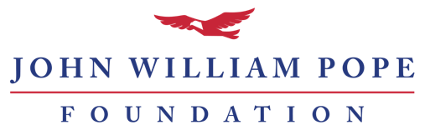

Future of Freedom Grant Report – Sixth Months

If your award letter indicates that you have received a Future of Freedom Grant from the John William Pope Foundation, you should use this report. If you need a copy of your award letter or have questions, please call the Pope Foundation at (919) 871-3329.

Guidelines
Please complete the report below. You may type directly into this document or compose your own document that addresses the bullet-pointed items. Reports should be submitted online at www.jwpf.org/reports. The report website allows you to upload your narrative, up to two additional documents (if needed), your renewal request, board of directors list, and IRS Form 990.

Part I: Narrative
Please share an update on the progress of your proposed project by answering the following questions:
- What actions have you taken to advance your project's objectives? Please include explanations of your internal and external activities as applicable.
- Do you still expect to achieve your proposed outcomes in the proposed timeline? If not, what has changed and why?
- Has the organization experienced any significant changes to date?
- Please attach or enter a full accounting of actual income and expenses for the project to date. Be sure to clarify how much of the Pope Foundation’s grant funds remain.

Part II: Renewal Request (optional)
If your organization would like to request another year of project funding, please prepare a renewal request letter that includes the following elements:
- A brief summary of your project (two paragraphs or less)
- The amount you are requesting
- A clear statement of need and explanation of how the additional funds will be used

Additionally, please provide the following documents with the letter:
- List of current board members (should include any position held on the board and the members' cities and states)
- Most recent 990 (signed and final copies only)

