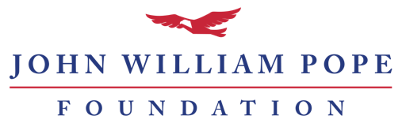

Annual Restricted Grant Report

If your award letter indicates that you have received a restricted ‘Annual Grant’ from the John William Pope Foundation, you should use this report. Do not use this report for ‘Future of Freedom’ or ‘Joy W. Pope Memorial’ Grants. If you need a copy of your award letter or have questions, please call the Pope Foundation at (919) 871-3329.

Guidelines
Please complete the report below. You may type directly into this document or compose your own document that addresses the bullet-pointed items. Typical reports are two to three pages long and should be submitted online at www.jwpf.org/reports. The report website allows you to upload your narrative report and up to two additional documents, if needed.

Please tell us about the progress of your restricted grant by including the following:
- Organization Name
- Award amount and award date
- Brief description of what activities the grant is funding (no more than one summary paragraph, please).
- Overview of key internal and external actions taken to advance the project/program since you received a grant from the Pope Foundation.
- Any significant changes have occurred within the project/program or the organization since you received a grant from the Pope Foundation (if applicable).
- Financial information about your grant:
  - If your restricted grant supports clients or activities from a particular geographic region, please submit a YTD income and expense report for the organization. Please note the number of clients you have served from that specific geographic area.
  - If your restricted grant supports a dedicated project/program, please share a YTD accounting of income and expenses for that project/program only.

