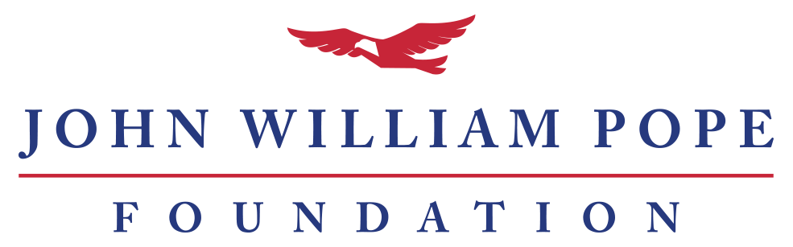

2019-2020 Grant Application Information

Thanks for your interest in applying for a grant from the John William Pope Foundation. Below you’ll find answers to commonly asked questions and information about our application process.

Who can apply for a grant?
To be eligible for a grant, an organization must be tax-exempt under IRS Code Section 501(c)3. The Pope Foundation cannot and does not make contributions to action organizations or to individuals. Organizations must have obtained their official tax-exempt status in order to receive funds from the Pope Foundation.

What are your core areas of giving?
The Pope Foundation’s core areas of giving include arts, human services, education, and public policy nonprofits. Please review our list of grantees and our stated mission to see if your organization and project fit with our giving focus.

What kind of grants do you make?
The Pope Foundation has most commonly made general operating grants, however all types of grant requests will be considered.

When should an organization apply for a grant?
We request public policy and education proposals by the last Monday in February and human services and arts proposals by the last Monday in August, each year. Urgent needs and projects that fall between meeting times may be considered at the discretion of the board.

How should an organization apply for a grant?
If possible, we ask that organizations use our online portal.

What information should be submitted?
Both the online and paper applications request the following information:

- Organization address, website, phone, fax; mission; and founding date
- Application contact information and CEO contact information including names, titles, emails, and phones
- Amount of request
- Brief summary of proposal

Additionally please attach as separate documents
- List of board members
- IRS tax exempt determination letter
- Form 990 (most recent)
- Audited financials (most recent) OR Most Recent Year-End Fiscal Statements that include basic balance sheet, income and expenses, and cash flows.
- Project-specific budget (if applicable)
- Long proposal
- Additional supporting documentation (if needed)

Mail grant requests to: John William Pope Foundation, Attn: Grant Request at 4601 Six Forks Rd, Ste, 300, Raleigh NC 27609.

When will we learn if our grant application was funded?
After receiving your application, we will confirm the receipt of your proposal with a mailed letter to the application contact. The board meets in the spring and fall but not on a permanently fixed schedule, so final notification dates may vary. However, all spring applicants will hear about the status of their application no later than June 30 and all fall applicants will hear about the status of their application no later than December 30. We thank you in advance for your patience as you wait for a reply.

COVER SHEET
Please complete and submit with your final grant application.

Organization Information
Name:
Physical Address:
Mailing Address:
City:
State:
Zip:
Website URL:
Phone Number:
Fax:

Application Contact (the individual who wants to receive updates about the status of the application)
Salutation:
First and Last Name:
Title/Position:
Phone:
Email:
Mobile:

Organization Leadership (CEO, Exec. Dir., President, etc.)
Salutation:
First and Last Name:
Title/Position:
Phone:
Email:

Short Proposal
Organization’s Mission Statement:
Amount of Request:
Summary of Proposal (200 characters or less):

Please attach as separate documents
- List of board members
- IRS tax exempt determination letter
- Form 990 (most recent)
- Audited financials (most recent) OR Most Recent Year-End Fiscal Statements that include basic balance sheet, income and expenses, and cash flows.
- Project-specific budget (if applicable)
- Long proposal
- Additional supporting documentation (if needed)

Mail grant requests to:
John William Pope Foundation
Attn: Grant Request
4601 Six Forks Road, Suite 300
Raleigh, NC 27609

